1. Write a Python Program to create a Database named “Store”. Display the List of Databases available in MySQL.

**import mysql.connector**

**mydb = mysql.connector.connect(**

***host* = "localhost",**

***user* = "root",**

***password* = "tapubrat56300*"**

**)**

**mycursor = mydb.cursor()**

**mycursor.execute("CREATE DATABASE STORE")**

**mycursor.execute("SHOW DATABASES")**

**for x in mycursor:**

**print(x)**

**mydb.close()**

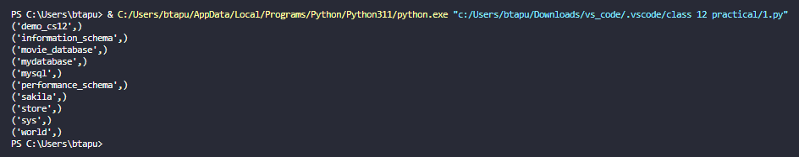

2. Write a Python program to Create a Table name “Products” under database “Store” containing Product name, category, price, and discount.

**import mysql.connector**

**mydb = mysql.connector.connect(**

***host* = "localhost",**

***user* = "root",**

***password* = "tapubrat56300*",**

***database*="STORE"**

**)**

**mycursor = mydb.cursor()**

**mycursor= mydb.cursor()**

**mycursor.execute("CREATE TABLE PRODUCTS (P_name VARCHAR(50),CATEGORY VARCHAR(50),PRICE INT,DISCOUNT FLOAT)")**

**print("table created")**

**mydb.commit()**

**mydb.close()**



3. Write a Python Program to Insert Records in “Product” table. Display all records.

**import mysql.connector**

**mydb = mysql.connector.connect(**

***host*="localhost",**

***user*="root",**

***password*="tapubrat56300*",**

***database*="STORE"**

**)**

**mycursor = mydb.cursor()**

**while True:**

**p_name=input("enter product name ")**

**ctrgy=input("enter the category of the product ")**

**pri=int(input("enter the price "))**

**dis=float(input("enter the discount allowed "))**

**sql = "INSERT INTO PRODUCTS (P_name, category,price,discount) VALUES (%s, %s,%s,%s)"**

**val = (p_name , ctrgy, pri, dis)**

**mycursor.execute(sql, val)**

**mydb.commit()**

**print(mycursor.rowcount, "data inserted")**

**more=input("do you  want to input more data to your table(y/n): ")**

**if more.lower()=="y":**

**continue**

**elif more.lower()=="n":**

**break**

**else:**

**print("invalid choice")**

**break**

**mycursor = mydb.cursor()**

**mycursor.execute("SELECT * FROM PRODUCTS")**

**myresult = mycursor.fetchall()**

**for x in myresult:**

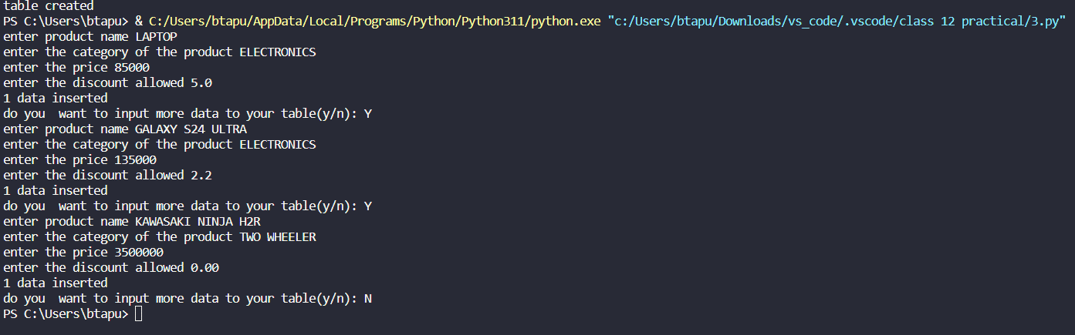

**print(x)**

**mydb.close()**

4. Write a Python program to increase the price of product whose name contains alphabet ‘a’ in it. Also display a message how many records are updated.

**import mysql.connector**

**mydb = mysql.connector.connect(**

***host* = "localhost",**

***user* = "root",**

***password* = "tapubrat56300*",**

***database*="STORE"**

**)**

**mycursor = mydb.cursor()**

**qry="update products set price=price*1.1 where p_name like '%a%' "**

**mycursor.execute(qry)**

**updated_records=mycursor.rowcount**

**mydb.commit()**

**print(f"{0} records updated",(updated_records))**

**mycursor.execute("SELECT * FROM PRODUCTS")**

**myresult = mycursor.fetchall()**

**for x in myresult:**

**print(x)**

**mydb.close()**

